**ADVANCE EXCEL ASSIGNMENT 1**

1. What do you mean by cells in an excel sheet?

Ans:

A cell is the intersection of a row and a column. Columns are identified by letters (A, B, C), while rows are identified by numbers (1, 2, 3). We need to insert data into the cells of an excel sheet in order to store/calculate and get information when required.

1. How can you restrict someone from copying a cell from your worksheet?

Ans:

We can protect our worksheet from getting copied which can be done by the following steps:

step 1. Go To Menu Bar -> Review -> Protect Sheet -> Password.

step 2. Enter password.

1. How to move or copy the worksheet into another workbook?

Ans:

Step1: Open both spreadsheets.

Step2: Right-click on the sheet you want to move.

Step3: click “Move or Copy.”

Step4: Click on the “To book” dropdown menu and find the workbook you want this sheet to move to.

Step5: Select the “Create a copy” checkbox at the bottom of the window.

Step6: Click “OK.”

1. Which key is used as a shortcut for opening a new window document?

Ans:

To quickly create a new blank file or email, press Ctrl+N.

1. What are the things that we can notice after opening the Excel interface?

Ans:

On opening the excel workbook we see a blank sheet having rows and columns and many options in the toolbar such as File, Home, Insert, Page Layout, Formulas as broad heads and many sub-options available inside every tab mentioned above also depicted in the picture below.

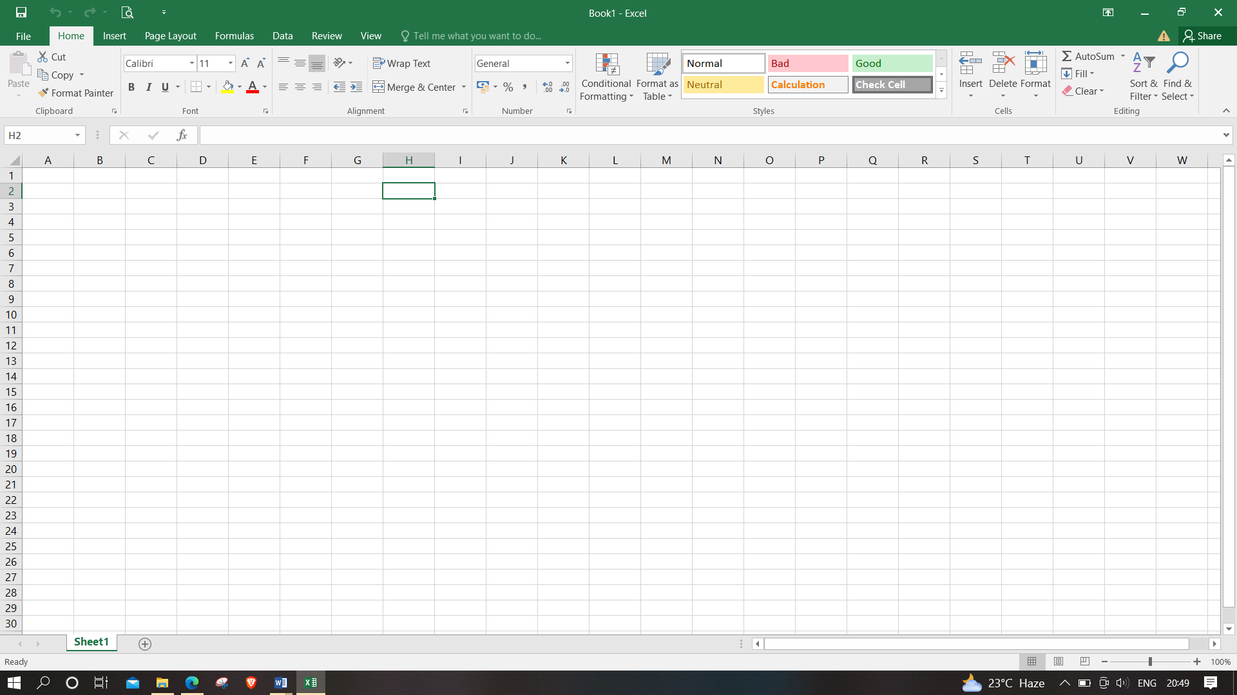

1. When to use a relative cell reference in excel?

Ans:

A relative reference in Excel means there’s a point of reference applied to a cell or a formula where the return value is relative to the cell location. This means the return value changes depending on where the cell or the formula moves to, within the same sheet or across different sheets. Relative reference is used when the same calculation is required across different rows or columns.